CHAIR CUSHION DHARMA
Practicing meditation here in the West does not necessarily include sitting in a half-lotus posture on a meditation cushion. Sitting on a chair is completely reasonable. I personally have sat through dozens of intensive residential retreats, alternating between sitting on a cushion with sitting on a chair, which is typically a stackable, straight-backed kitchen or office chair. These chairs tend to mysteriously get harder and harder as the retreat progresses!

I recently discovered an arrangement of cushions that suited me admirably for the two-week self-retreat I recently completed. I was so grateful I took photos to show the arrangement, hopeful that it will be helpful for others. For those reading this who are considering attending a one week residential retreat, here are some images to illustrate what I created:

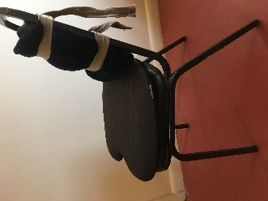
This side view shows the total arrangement.
The cushion was bought at Costco for about $15.
The back support is two cushions: One is somewhat stiffer, and the one next to my lower back is more foamy. The straps are cinch belts I had around the house.

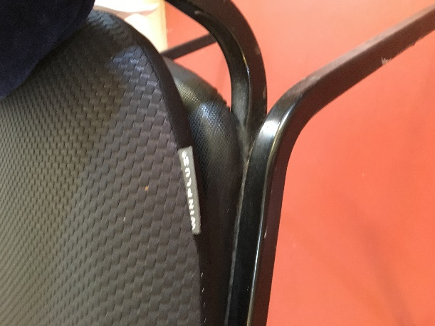
This is the label for the cushion; manufactured by “Winplus”. I imagine it can be found and purchased online. I think it’s meant to be used for football games. It is the most comfortable cushion for my bony little butt, and I can sit in this chair for two hours or more comfortably. Without a cushion or with a different cushion, two hours would be uncomfortable.

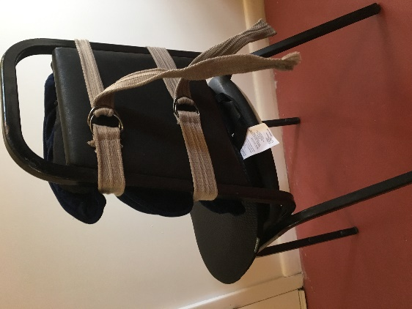
I also placed a folded meditation mat under my feet so the cushion doesn’t cut off circulation to my legs. I hope this is helpful. I wish you well. Peter Carlson
This is the strapping arrangement. I believe two bungie cords would also suffice. The lower strap would be around my beltline, and the upper would be somewhere in the mid-back area. I find it useful to have the cushioned “bump” to press into the lower back softly.

